For account key create key vault and use it in databricks as scope

1. Go to key vault create

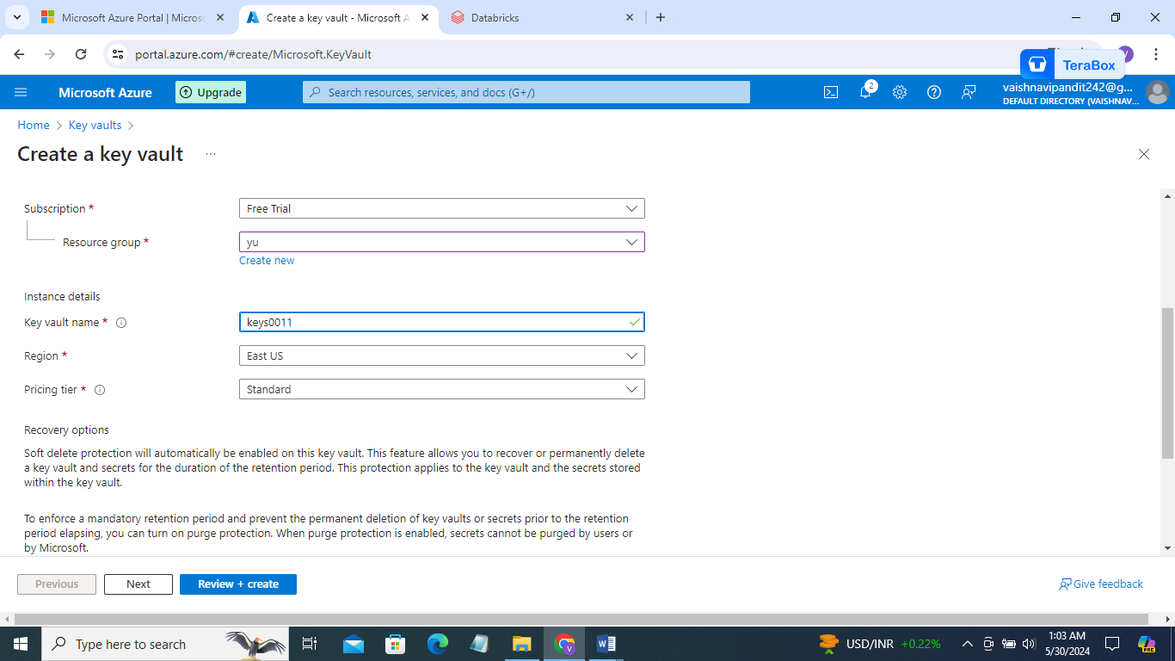

1. Go to acces configuration enable vault access policy
2. Now go to scerets create

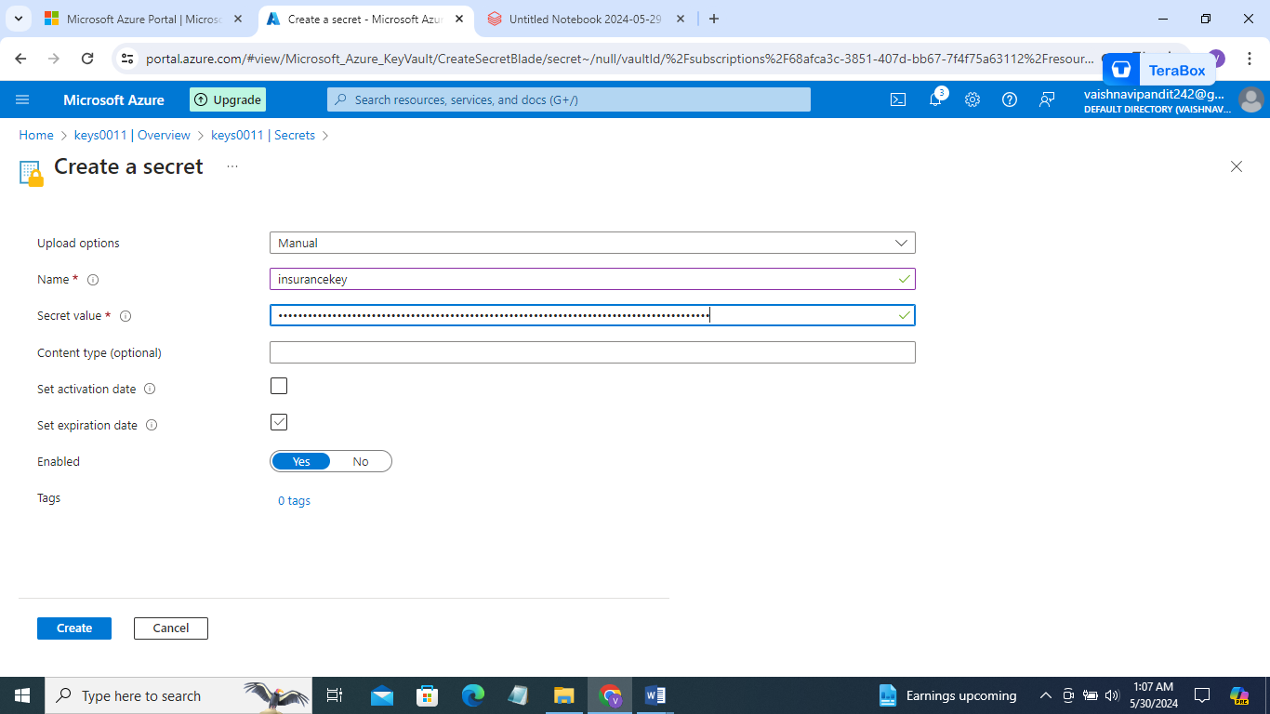

1. Now go to databricks copy url and add #secrets/createScope in it

Databricks url:

[https://adb-3651610251102150.10.azuredatabricks.net](https://adb-3651610251102150.10.azuredatabricks.net/)

Scope link:

<https://adb-3651610251102150.10.azuredatabricks.net#secrets/createScope>

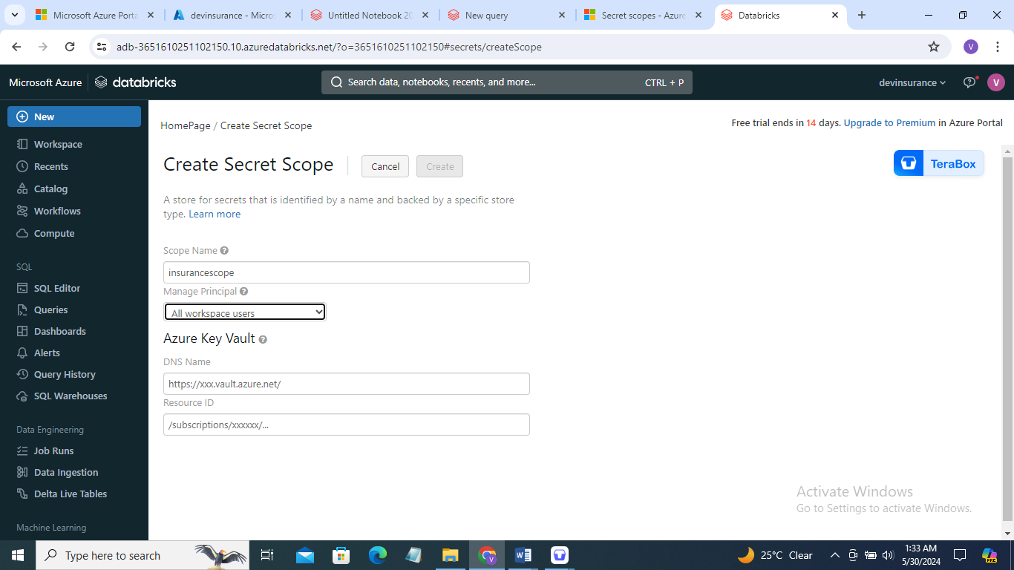

1. Get dns name and resource id from keyvault by going in properties

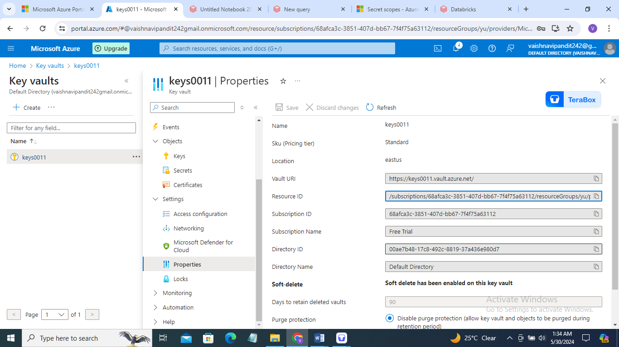

In overview you will find key url that is dns name

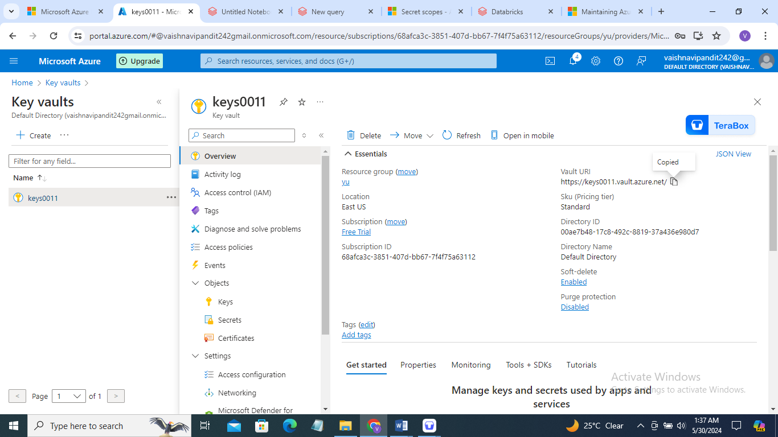

1. Now go to databricks paste it there

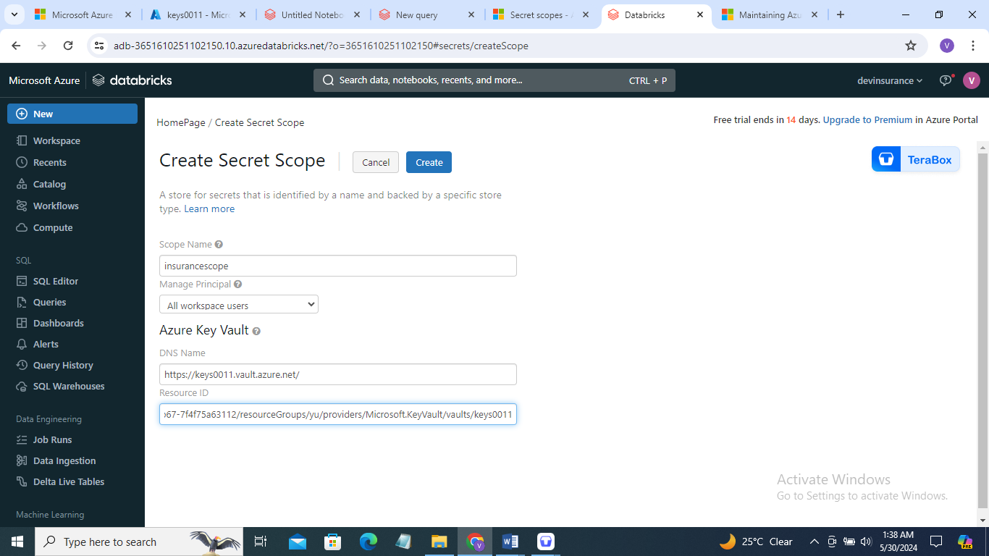

1. Create
2. Now go to notebook and use the insurancescope at the place of account key
3. spark.conf.set('fs.azure.account.key.dev0011insuranceaccount.dfs.core.windows.net', dbutils.secrets.get(scope='insurancescope',key='insurancekey'))